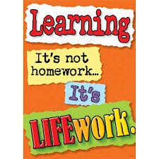Nightly Homework Schedule Grade 4-1
September 3-7th 2012
 | Monday | Tuesday | Wednesday | Thursday
Nightly Reading | Read for 20 minutes and complete your reading record log.
Writer’s Notebook | A writer’s notebook is a launch pad or workbench for larger projects. A good place to free-write, record wonderings, observations, conversations, sketches, or memories. A writer's notebook gets you to notice things, to observe things, to think and discover. It is a place for students to "grow" ideas and develop their writer's craft. Write 2 entries this week! Remember to date your entries and try to write ½ to 1 page for each entry.
Mathematics | Math workbook pages 18,21,22, and 24. Play the game Multiplication Cards at home. All game materials should be kept in your math games folder at home.
Technology
Science
Social Studies | Mini research at home/use your atlas to help you-write in your interactive notebook:  - Draw a map of Thailand  - Write in the names of the bodies of water  - Names of the surrounding countries/capital cities  - Write the names of 3 rivers in Thailand-draw and label  - Write the name of 1 mountain range in Thailand-draw and label  - Write the names of 5 major cities in Thailand-including Bangkok  - Highlight 5 major regions/name them/label

