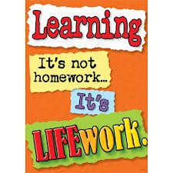Nightly Homework Schedule Grade 4-1
September 24-28th 2012
 | Monday | Tuesday | Wednesday | Thursday
Nightly Reading | Read for 20 minutes and complete your reading record log.
Writer’s Notebook | A writer’s notebook is a launch pad or workbench for larger projects. A good place to free-write, record wonderings, observations, conversations, sketches, or memories. A writer's notebook gets you to notice things, to observe things, to think and discover. It is a place for students to "grow" ideas and develop their writer's craft. Write 2 entries this week! Remember to date your entries and try to write ½ to 1 page for each entry.
Mathematics | Play your choice of the math games sent home with a partner. All game materials should be kept in your math games folder at home.
Technology | Check out our new homework blog! Post a comment or reply if you have questions or want to share ideas with a classmate.
Science
Social Studies | Go to this website: http://www.worldatlas.com/webimage/countrys/find.htm Choose 5 countries and record the absolute and relative location for a city in each country. Remember to write the name of the city and country.

