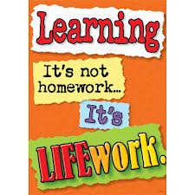Nightly Homework Schedule Grade 4-1
September 10-14th 2012
 | Monday | Tuesday | Wednesday | Thursday
Nightly Reading | Read for 20 minutes and complete your reading record log.
Writer’s Notebook | A writer’s notebook is a launch pad or workbench for larger projects. A good place to free-write, record wonderings, observations, conversations, sketches, or memories. A writer's notebook gets you to notice things, to observe things, to think and discover. It is a place for students to "grow" ideas and develop their writer's craft. Write 2 entries this week! Remember to date your entries and try to write ½ to 1 page for each entry.
Mathematics | Math workbook pages 26,36,37, and 38. Play the game Multiple Turn Over at home. All game materials should be kept in your math games folder at home. Please return the recording sheet on Friday.
Technology | Post a comment and a reply on our class blog.
Science
Social Studies

