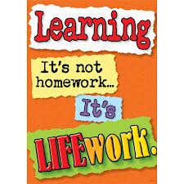Nightly Homework Schedule Grade 4-1
Apr. 29 – May 3, 2013
 | Monday | Tuesday | Wednesday | Thursday
Nightly Reading | Read for 25 minutes and complete your reading record log.
Writer’s Notebook | A writer’s notebook is a launch pad or workbench for larger projects. A good place to free-write, record wonderings, observations, conversations, sketches, or memories. A writer's notebook gets you to notice things, to observe things, to think and discover. It is a place for students to "grow" ideas and develop their writer's craft. Write 3 entries this week! Remember to date your entries and try to write ½ to 1 page for each entry.
Mathematics | Complete pages 40, 42, 43, 47, 48, 49, 50, 51, 52 and 53 for Unit 5 in your math workbook. Play the game Close to 1,000 and record your work on page 31 in your student book. Any unfinished workbook pages should be completed at home.
Technology | Please visit www.typingweb.com to practice your keyboarding skills. Try to practice for 10 minutes each day! Type out 1 of your poems using a google doc and add images by Friday.
Social Studies | Describe the roles of laws, courts of law and judges in a country. Answer this question in paragraph form giving examples and details about what this means. Share your work with me on a google doc.

