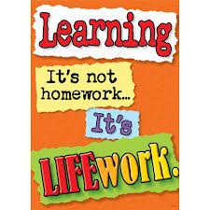Nightly Homework Schedule Grade 4-1
October 8-12, 2012
 | Monday | Tuesday | Wednesday | Thursday
Nightly Reading | Read for 25 minutes and complete your reading record log.
Writer’s Notebook | A writer’s notebook is a launch pad or workbench for larger projects. A good place to free-write, record wonderings, observations, conversations, sketches, or memories. A writer's notebook gets you to notice things, to observe things, to think and discover. It is a place for students to "grow" ideas and develop their writer's craft. Write 3 entries this week! Remember to date your entries and try to write ½ to 1 page for each entry.
Mathematics | Please complete pages 3,6,15, and 16 in your math workbook.
Technology | Check out our October Newsletter and our new newsletter blog!
Science
Social Studies | Record 5 human characteristics and physical characteristics to describe a place (country) that you have selected in your interactive notebook. Make a T-chart!

