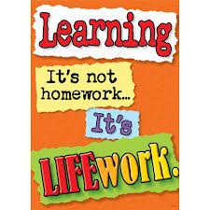Nightly Homework Schedule Grade 4-1
October 29-Nov. 2, 2012
 | Monday | Tuesday | Wednesday | Thursday
Nightly Reading | Read for 25 minutes and complete your reading record log.
Writer’s Notebook | A writer’s notebook is a launch pad or workbench for larger projects. A good place to free-write, record wonderings, observations, conversations, sketches, or memories. A writer's notebook gets you to notice things, to observe things, to think and discover. It is a place for students to "grow" ideas and develop their writer's craft. Write 3 entries this week! Remember to date your entries and try to write ½ to 1 page for each entry.
Mathematics | Please complete pages 18,23,24, and 29 in your math workbook.
Technology | Submit your Boomwriter draft by Tuesday morning! Then, on Tuesday and Wednesday evenings please vote on which entry should be included as our second chapter.
Science
Social Studies | Research your country of choice for your Five Themes of Geography Project and fill out the worksheet with the information you collected. Please return your research worksheet on Friday. We will use the information you collected to make your Google presentation.

