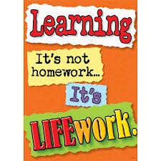Nightly Homework Schedule Grade 4-1
October 15-19, 2012
 | Monday | Tuesday | Wednesday | Thursday
Nightly Reading | Read for 25 minutes and complete your reading record log.
Boomwriter | Please complete your first chapter and submit it to the editor. All chapters must be submitted by Thursday afternoon!
Mathematics
Technology | Check out our October Newsletter and our new newsletter blog! Post a comment and a reply on our class blog.
Science
Social Studies | Choose a country for your 5 Themes of Geography project. Find one picture from the past and the present from the country you chose and then describe how humans have changed or altered the environment. Paste your past picture on one side of your paper and the present on the other side. The work can be done in your notebook or on a separate sheet of paper.

