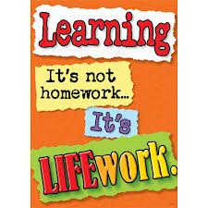Nightly Homework Schedule Grade 4-1
November 5 - 9, 2012
 | Monday | Tuesday | Wednesday | Thursday
Nightly Reading | Read for 25 minutes and complete your reading record log.
Writer’s Notebook | A writer’s notebook is a launch pad or workbench for larger projects. A good place to free-write, record wonderings, observations, conversations, sketches, or memories. A writer's notebook gets you to notice things, to observe things, to think and discover. It is a place for students to "grow" ideas and develop their writer's craft. Write 2 entries this week! Remember to date your entries and try to write ½ to 1 page for each entry.
Mathematics | Please complete pages 37, 38, 41, and 42 in your math workbook.
Technology | BOOMWRITER: Please complete your second and final chapter and submit it to the editor. All chapters must be submitted by Friday afternoon! Check out our November Newsletter on our class website www.josephbuscemi.weebly.com
Science
Social Studies | Continue working on your Five Themes of Geography Google Presentation. We will also have time to work on it as a class in the computer lab this week.

