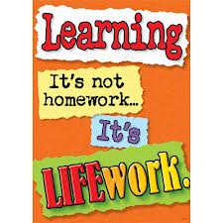Nightly Homework Schedule Grade 4-1
November 19 - 23, 2012
 | Monday | Tuesday | Wednesday | Thursday
Nightly Reading | Read for 25 minutes and complete your reading record log.
Writer’s Notebook | A writer’s notebook is a launch pad or workbench for larger projects. A good place to free-write, record wonderings, observations, conversations, sketches, or memories. A writer's notebook gets you to notice things, to observe things, to think and discover. It is a place for students to "grow" ideas and develop their writer's craft. Write 3 entries this week! Remember to date your entries and try to write ½ to 1 page for each entry.
Mathematics | Please complete any unfinished work you have for Unit 2 in your math workbook.
Technology | Please comment and reply on our class blog. Also, visit www.typingweb.com to practice your keyboarding skills.
Unfinished Work | Please complete any unfinished tasks or assignments.
Social Studies | Upload your Five Themes of Geography Google Presentation onto our class Posterous site. If you need help or assistance please talk to Mr. Joe.

