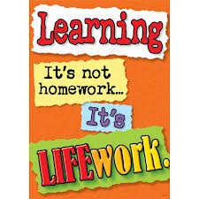Nightly Homework Schedule Grade 4-1
November 12 - 16, 2012
 | Monday | Tuesday | Wednesday | Thursday
Nightly Reading | Read for 25 minutes and complete your reading record log.
Writer’s Notebook | A writer’s notebook is a launch pad or workbench for larger projects. A good place to free-write, record wonderings, observations, conversations, sketches, or memories. A writer's notebook gets you to notice things, to observe things, to think and discover. It is a place for students to "grow" ideas and develop their writer's craft. Write 2 entries this week! Remember to date your entries and try to write ½ to 1 page for each entry.
Mathematics | Please complete the Unit 3 Pre-Assessment Worksheet
Technology | BOOMWRITER: Please complete your second and final chapter and submit it to the editor. All chapters must be submitted by Tuesday afternoon. Voting will begin on Wednesday!
Scholastic | Please return all forms and fees by Wednesday!
Social Studies | Continue working on your Five Themes of Geography Google Presentation. We will also have time to work on it as a class in the computer lab this week. All Presentations are due by Friday!

