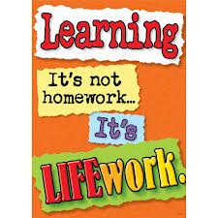Nightly Homework Schedule Grade 4-1
December 3 - 7, 2012
 | Monday | Tuesday | Wednesday | Thursday
Nightly Reading | Read for 25 minutes and complete your reading record log.
Writer’s Notebook | A writer’s notebook is a launch pad or workbench for larger projects. A good place to free-write, record wonderings, observations, conversations, sketches, or memories. A writer's notebook gets you to notice things, to observe things, to think and discover. It is a place for students to "grow" ideas and develop their writer's craft. Write 3 entries this week! Remember to date your entries and try to write ½ to 1 page for each entry.
Mathematics | Please play the game Multiplication Practice and Small Array/Big Array.
Technology | Please visit www.typingweb.com to practice your keyboarding skills. Try to practice for 10 minutes each day!
Social Studies | Complete the worksheet on Why Do People Immigrate and return it with your homework on Friday.

