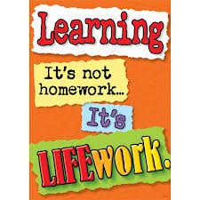Nightly Homework Schedule Grade 4-1
Apr. 22 – Apr. 26, 2013
 | Monday | Tuesday | Wednesday | Thursday
Nightly Reading | Read for 25 minutes and complete your reading record log.
Writer’s Notebook | A writer’s notebook is a launch pad or workbench for larger projects. A good place to free-write, record wonderings, observations, conversations, sketches, or memories. A writer's notebook gets you to notice things, to observe things, to think and discover. It is a place for students to "grow" ideas and develop their writer's craft. Write 3 entries this week! Remember to date your entries and try to write ½ to 1 page for each entry.
Mathematics | Complete pages 27, 28, 29, 30, 32, 33, 35, 36, 37 and 39 for Unit 5 in your math workbook. Play the game Close to 1,000 and return the recording sheet on Friday. Any unfinished workbook pages should be completed at home.
Technology | Please visit www.typingweb.com to practice your keyboarding skills. Try to practice for 10 minutes each day!
Social Studies | Explain what citizenship is and what it means to be a citizen of a nation. What are your rights and responsibilities as a citizen? Do citizens of all nations enjoy the same rights and responsibilities? In your opinion is citizenship a right or a responsibility? Share your work with me on a google doc titled ‘Citizenship’.

