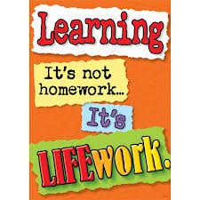Nightly Homework Schedule Grade 4-1
Apr. 1 – Apr. 5, 2013
 | Monday | Tuesday | Wednesday | Thursday
Nightly Reading | Read for 25 minutes and complete your reading record log.
Writer’s Notebook | A writer’s notebook is a launch pad or workbench for larger projects. A good place to free-write, record wonderings, observations, conversations, sketches, or memories. A writer's notebook gets you to notice things, to observe things, to think and discover. It is a place for students to "grow" ideas and develop their writer's craft. Write 3 entries this week! Remember to date your entries and try to write ½ to 1 page for each entry.
Mathematics | Complete pages 14, 15, 17, 18, 19, 21, 22, 23, 25 and 26 for Unit 5 in your math workbook. Complete the Unit 6 Pre assessment using your Pearson account. Any unfinished workbook pages should be completed at home.
Technology | Please visit www.typingweb.com to practice your keyboarding skills. Try to practice for 10 minutes each day!
Social Studies | Choose 1 form of government and be prepared to explain how that type of government operates to the class. Prepare a Google doc and share it with me outlining the form of government you chose. In your opinion is this a “good” form of government? Explain?

